**ST. XAVIER’S COLLEGE**

**(Affiliated to Tribhuvan University)**

**Maitighar, Kathmandu**



**SIMULATION AND MODELING LAB REPORT #03**

**SUBMITTED BY:**

Pradeep Dahal

017BSCIT029

3rd year/ 5th Sem

|  |  |
| --- | --- |
|  | Signature |
| Mr. Ganesh Yogi  (Lecturer) |  |
| Department of Computer Science | |

**SUBMITTED TO:**

**TITLE: TO SIMULATE THE OCCURANCE OF NUMBERS FROM 1-6 IN THREE DICES USING EXCEL.**

**THEORY:**

Probability is the study of chance. We use the laws of probability to understand the chances of successful outcomes in our uncertain world. When approached with a question about probability, a good first step is to consider all possible results of observing the outcomes of a chance event. This collection of all these outcomes is also known as the sample space.

If you roll a fair **dice**, you’ll get any **number b**etween 1 and 6. And we have the probability of getting a number with a probability of 1/6.Therefore, we simulate the occurrence of numbers in dices in the excel.

**RESULT:**

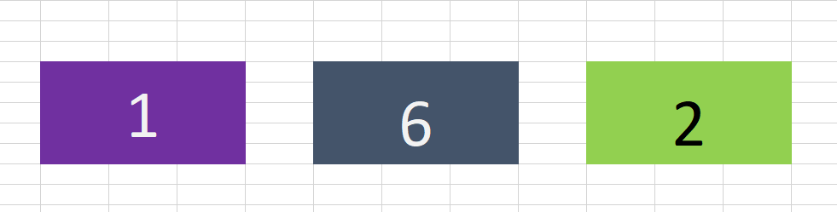

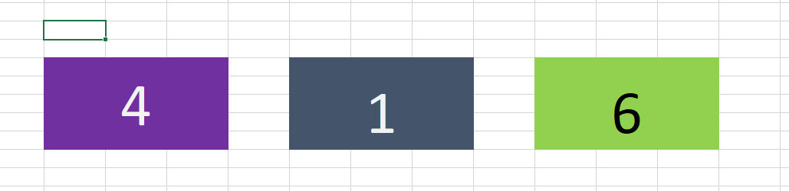

For first, the formula in the excel sheet is given by:

=RANDBETWEEN(1,6)

For second, the formula in the excel sheet is given by:

=RANDBETWEEN(1,6)

For second, the formula in the excel sheet is given by:

=RANDBETWEEN(1,6)

**CONCLUSION**

Hence, the occurrence of numbers in three dices is simulated in Ms. Excel. The random number of the dices found to be 1,6 and 3 in first, second and third respectively.